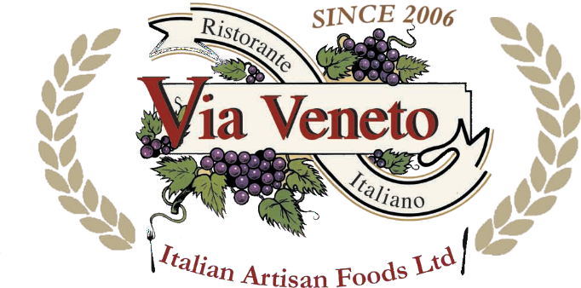 OUR WINE LIST
by

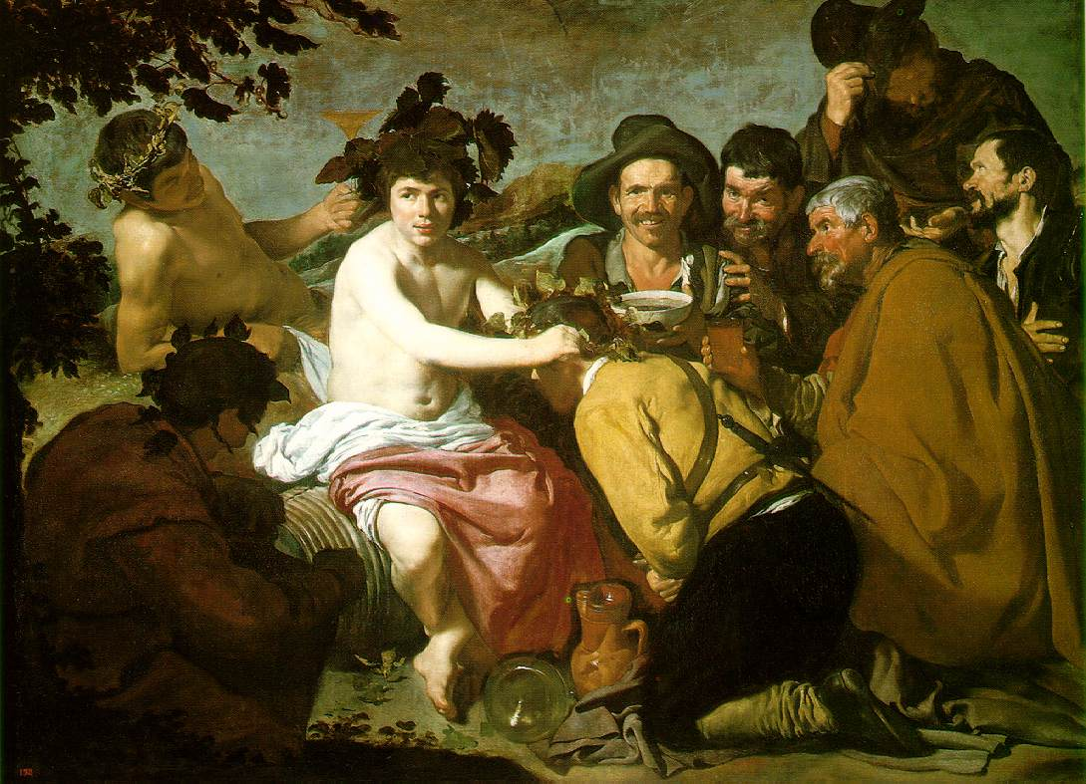

Day-coloured wine, night-coloured wine, wine with purple feet or wine with topaz blood, wine, starry child of earth, wine, shoots a golden sword, soft as lascivious velvet, wine, spiral-sea shelled and full of wonder, amorous, marine; never has one goblet contained you, one song, one man, you are choral, gregarious, at the least, you must be shared. Pablo Neruda
White Wines

1. Pinot Grigio €25.00
Crisp, fresh and fruity wine. Very elegant, soft and delicate with hints of hazelnuts on the finish.

2. Grillo €27.00
This Sicilian white opens with a bright, fresh, demeanour offering notes of citrus with a fine backdrop of minerality. The site is an ancient seabed of calcareous remains, and you can taste the electricity the soil injects into the wine. Perfect with a summer corn salad, or a fall shellfish boil.
2. Gavi di Gavi €29.00
This pale straw yellow wine displays green apple aromas with vanilla flavors and a certain
minerality. This elegant, pleasant, fresh and harmonic.

3. Chardonnay €25.00
Yellow with green hints. Delicate and fruity in character, offering banana and tropical fruit.
Good complexity with a hint of soft vanilla with a pleasing and enjoyable acidity; a long finish.

4. Pecorino €27.00
Intense floral aromas, well balanced and fresh, with good length.

5. Sauvignon Blanc €26.00
Concentrated aromatics with scents of lilac, wild flowers and nuts. Ripe melon, papaya and some spice are present in the palate while the finish is long and smooth.

6. Trebbiano Rubicone €25.00
A light and crisp wine, with hints of apple and wild flower in the aromas. Dry and full of character
with a distinct acidity on the palate.

7. Soave €26.00
Aromatic with a slightly flinty, refreshing flavor. This wine reveals the characteristic almond
finish and a persistent bouquet.

8. Frascati €25.00
Aromatic with a slightly flinty, refreshing flavor. This wine reveals the characteristic almond
finish and a persistent bouquet.

9. Falanghina €28.00
Straw yellow in color. A fruity bouquet with apricot and peach notes. Its smooth, elegant and full bodied.

10. Pinot Grigio Castel Firmian €29.00
The bouquet is unmistakable and immediate, with an intense impression of acacia flowers.

11. Custoza €28.00
This young and fruity wine has a pale-yellow color. The taste is dry, pleasant, and fresh.

12. Sauvignon Blanc Castel Firmian €28.00
The bouquet is aromatic and characteristic. Dry, pleasant and velvety with a good body on the palate

13. Verdicchio €28.00
Dry and delicate and fresh with hints of hazelnuts and a refreshing fruitiness. Elegant white wine.

14. Gewürztraminer €30.00 Pale yellow. Softish nose with sweet cinnamon. Full bodied and off-dry. Low acidity. Flavoursome and pleasant but best with fruit rather than savoury food

15. Pinot Grigio Millesimato €32.00
the pinot grigio varietal has been cultivated for a long time in the Valle dell` Adige, where it is also referred to as Rulander. The bunches of grapes, “copper-grey” in colour, reveals its close relationship to the Pinot Nero varietal, from which it is derived. Pinot Grigio Millesimato is born from grapes cultivated in the vineyards of the “Zablani”, zone, specific to his varietal. Situated northeast of Mezzocorona and characterized by watery soils with good drainage, it is very similar to the neigh boring zone,

16. Fiano di Avellino €35.00
Made from the local Fiano grape around the town of Avellino, this is one of the most popular white wines from Campania. A multitude of aromas including pear, pineapple, toasted nuts and honey.

17. Greco di Tufo €35.00
“A quirky but very enjoyable wine; pear fruits, with a distinctive background of almonds and a dry mineral finish. Well worth a try”

18. Passerina €28.00
Vigna Madre produces this Vigna Madre Passerina Bio, a white wine from the region Abruzzo made of Passerina grapes. Citrus fruits, yellow fruit aroma, with white meat, it is also excellent as an aperitif

Rose Wine
19. Pinot Grigio Rose €25.00
Crisp, fresh and fruity wine. Very elegant, soft and delicate with hints of hazelnuts on the finish.

20. Rose Feudo Arancio €29.00
Is a light-bodied red grape widely grown on the south-eastern coast of Sicily. The grape is of great historical importance, both for its wines and its legislative influence.

Sparkling wine

21. Prosecco €33.00
Pleasant and extremely elegant, full of delightful, floral-based hints. Lovely fine mousse, off dry and crisp

22. Rotari Brut €38.00
Forthcoming, fresh and lasting, with significant overtones of ripe golden apples and wildflowers and a sublet and delicate fragrance of yeast. Clean and balanced length. A great all-rounder for any fish, seafood or white meat.

23. Prosecco Millesimato €37.00
Bright straw yellow; very fine and persistent perlage. Nose: Fruity bouquet; notes of apple, pear, citrus and white flowers. Mouth: Soft and elegant, with a savoury and persistent taste; light and pleasantly lively.

Red Wines
23. Montepulciano €27.00
Medium bodied, ruby red. Intense ripe bramble fruit aromas. Good body and lovely fruity finish.

24.Sangiovese del Rubicone €28.00
Sangiovese Rubicone has an intense ruby red color. The nose can smell delicate aromas of violets and red fruits. The palate is beautifully balanced with fine tannins which combine well with the red fruit.

25. Aglianico €28.00
A generous and enveloping bouquet with hints of violets and ripe bilberries. On the palate it is
full and velvety, with a pleasant lingering aftertaste.

26. Pinot Nero €28.00
Full bodied, warm ripe on the nose, intense and of great refinement with distinct notes of dried
cherries and plums with a lingering aftertaste

27. Merlot €25.00
ruby red and tending to Burgundy red hues. Intense, persistent with complex scent of spices intensely vinous, harmonic.
24. Marzamino Castel Firmian €29.00
Pure nose with aromas of small fruits. A fruity, elegant taste; good balance in the mouth and a fresh fruity finish with very fine, silky tannins.

28. Teroldego Rotaliano Mezzacorona €32.00
The Prince of Trentino wines, it boasts a ruby red and a velvety taste with hints of woodland fruit. Excellent for serving with roasts, grills and mature cheeses.
29. Chianti €29.00
Ruby red tending to Burgundy-red hues. Intense, persistent with complex scents of spices. Intensely
vinous, harmonic.

30. Barbera D’Asti La Villa €35.00
Accentuated, bright ruby red colour accompanied by a bouquet with a nicely vinous and intense finesse, featuring pleasant scents of cherry and fruits of the forest. The palate is full of body, with a pleasant and lingering finish.
31. Valpolicella Ripasso €33.00
Rich spicy black pepper nose with a hint of truffle. Fairly intense, spicy, sweet cherry flavours.
Well balanced and full of flavors.

32. Salice Salentino Riserva Carta €30.00
Rich fruit with flavors of sweet blackberries & plums, warm and lightly spicy on the palate with
long acidity and round tannins.

33. Primitivo del Salento €29.00
Intense, full ruby. Rich and spicy on the nose, very harmonious. Well-structured on the palate,
concentrate, round, well balanced with strong but sweet tannins on a pleasantly bitter background.

34. Cabernet Sauvignon Castel Firmian €30.00
Intense, penetrating, characteristic aromas suggestive of the underbrush, with ageing it recalls
spices and becomes almost velvety. Excellent body, full and dry, refines with ageing.
35. Valpollicella Ripasso €35.00
Rich spicy black pepper nose with a hint of truffle
Fairly intense, spicy, sweet cherry flavours. Well balanced and full of flavours. White pasta, pizza, vegetables, white and red meat, fresh cheeses

36. Chianti Classico €33.00
Vivacious ruby red in colour. Intense and fruity with a violet fragrance and slight hint of cherries.

37. Nobile di Montepulciano Tre Rose S. Caterina €45.00
Ruby red with garnet reflections. Intense, persistent and fruity. Full body, good tannins and well
balanced.

38. Barbera D’Asti Terredavino €28 .00
. Lean and racy mouthfeel, with fairly high acidity. The tart cherry comes back strong on the back end, with a touch of bitter almonds and chocolate.
39. Valpollicella Ripasso Tommasi €38.00
Rich spicy black pepper nose with a hint of raisins. Full body, very intense, spicy, sweet cherry
flavours with a long opulent finish

40. Morellino di Scansano €33.00
Sangiovese 85%, Cabernet asd Merlot 15%. Cultivated in Tuscany, Maremma, the DOC region of Morellino di Scansano. Each variety is picked separately, gently crushed and fermented in stainless steel tanks. Subsequent aging for eight months in barrels of Slavonian oak and bottle aging for two months. This elegant and fruity wine is ideally suited for venison and ages cheese. With flavorful fish it can give rise to new, suggestive sensations.

41. Merlot Castel Firmian €29.50 This red grape variety is famous unmistakable suppleness. Exclusive estate production of the vineyards located in the most suitable area to the north of Lake Garda. An elegant wine of great character with pleasant wild-berries notes.

42. Syrah Feudo Arancio €30.00
This wine has won many prizes: This wine has won the Mundus Vini Gold award for the 2015 vintage and the 2009 vintage. This Sicily wine has received good scores from various critics.
Above average in popularity among wines from this region. There has been a lowering of demand in the past year.

43. Bardolino €29.00
Vineyards in the hills of the Classico area on the east side of lake Garda. Intense ruby red colour, fruity and fragrant aroma, velvety balanced taste.

44. Tombacco Biferno Rosso Riserva €.35.00
A velvety wine with a full flavour that, like the river from which it takes its name, it leads the way in lands at one with the sea and ancient traditions.
The brilliance of the garnet reflections on an intense ruby red, the Biferno is a wine with a full and aromatic taste.. Great matching with Italian traditional sausage and aged cheese.

45. Amarone della Valpollicella Tommasi € 85.00
After harvest, the grapes are placed on small racks in a large grape-drying room known as a fruttaio, where they are dried by cool autumn and winter breezes until the following February. Over these months the grapes lose about 50% of their weight, concentrating the level of natural sugar. After a fermentation period lasting 20 days, the wine is aged for 3 years in large 35-hectoliter Slavonian oak casks, followed by one year in bottle.
Tasting Note: Deep ruby red colour with garnet shades. Warm, ripe on the nose, intense and of great refinement. The taste is complex, smooth, full bodied, lots of cherry notes and plum.
Color Red: Grape varieties Corvina, Corvinone, Oseleta, Rondinell
Appellation:Amarone della Valpollicella DOCG: Farming: Biological Pest Control, Alcohol: 15 %

46.Barbera D’Asti €.28.00
This Barbera d' Asti DOCG made with Barbera grapes owes its structure, great harmony and softness, to a short period of aging in bottle. A wine of intense red colour, with a vinous, pronounced, dry perfume; full-bodied with a soft and an ample taste.
47. Nero di Troia €.30.00 Aromas of violets, red and black fruits with notes of vanilla, star anise, herbs and spice. These are followed by flavours of raspberry, cherry, plum and blackberry along with cedar, tobacco, leather and dark chocolate, leading to a persistent finish.

Special Wines

138. Brunello di Montalcino Gaja Rennina 2000 €180.00
A most impressive Brunello with big spicy earthy character, black fruit, truffle and tar, on the palate, the texture is very silky with delicious flavours of black fruit and minerals along with forest floor and eucalyptus.

139. Barbaresco Angelo Gaja 2003 €265.00
Very very good wine, very elegant in the nose with red mature fruits, menthol, chocolate and spices Low density Middle tannins Long aftertaste and good retro taste

140. Angelo Gaja Conteisa Nebbiolo delle Langhe 2001 €250.00
The full body and the elegant texture of ripe tannins as a quintessence of the area and the Nebbiolo-grape are typical of this artful wine. A great wine with an unusual potential.

141. Angelo Gaja Ca’ Marcanda Promis 2006 €95.00
The Gaja Ca 'Marcanda Promis has a ruby ​​red colour, wonderfully fragrant bouquet of red fruit flavors of ripe raspberries, good structure, hints of toasted bread.

142. Angelo Gaja Ca’ Marcanda Magari 2006 €90.00
Angelo Gaja, who with the Magari gives us yet another wine of the highest quality and elegance. Red with a bright garnet colour, very concentrated. The nose is initially expressed with balsamic and mineral...

143. Sagrantino di Montefalco Rocca dei Fabbri 2002 €75.00
Intense and full wine with chocolaty notes on the nose, masses of black fruits with beefy, savoury notes on the palate. Sagrantino is the grape variety and specially of the region, a marvellous wine that will well reward keeping

144. Angelo Gaja Sito Moresco 2006 €90.00
Ruby. Pure nose with aromas of small fruits. A fruity, elegant taste; good balance in the mouth and a fresh fruity finish with very fine, silky tannins. Ideal to drink young but matures well for at least 5-7 years.

145, Oriel Italy Barolo Etereo 2000 €150.00
Barolo, Fragrant, tannic Barolo wine is so revered that it was one of just three wines awarded DOCG status on the day that the classification was introduced in July 1980

146. Oriel Taralula Tuscany 2002/2003 €85.00
Essentially a Brunello di Montalcino in all but name. Plums and cherries, elegant, balanced ultra-smooth. Careful pruning and mineral intervention winemaking tied to the phases of the moon. Aged for 20 months in French oak

147. Barolo S.Orsola 2006 €75.00
Barolo wines are distinguished by their strong tannins, high acidity and distinctive scent – often described as "tar and roses". A less obvious characteristic, visible only over time, is their tendency to lose color.

148. Barbaresco S.Orsola 2006 €75.00
The grape variety behind the top-quality red wines of Piedmont, north-western Italy, Barbaresco wines are distinguished by their strong tannins, high acidity and distinctive scent – often described as "tar and roses". A less obvious characteristic, visible only over time.

149. Brunello di Montalcino 2005 Brunaio €115.00
Following a hot summer, the middle of the grape harvest was hit by the cold and heavy rain showers. This produced an intense ruby, young and bright Brunello that evokes an aroma bursting with forest fruits, currants and raspberries. The young flavour is elegant, velvety and lingeringly simple.

150. Gran Masetto Teroldego 2004 Endrizzi €130.00
Endrizzi produces the Teroldego Rotaliano, an extraordinary, autochthonous grape of Trentino. A partisan, concentrated, and intense red wine of highly selected Teroldego grapes, half of which are dried after picking and then ripe for a long time in oak barrels – hints of ripe, dark berries, vanilla, and smoky aromas

151. Tasca d’Almerita Regareali Rosso del Conte 2001 €120.00
This is the special reserve of Tasca d’Almerita. Made from the local Nero d’Avola grape from plants more than forty years old, cultivated as shrubs - a system which is almost unique in Sicily today.

152. Sandrone Barolo Cannubi Boschis 2003 €170.00
Lacks a bit of depth and complexity. Round fine tannin and good acidity with an earthy finish. A lot leaner than expected.
Bottle opened 2 weeks later. Fine aromas with roses and secondary notes of some deep forest floor. Fresh with good acidity levels, round with fine tannin. Soft plush fruit. Long finish with great balance.

153. Sandrone Valmaggiore Nebbiolo d’Alba 2005 €85.00
A ruby red colour with violet reflection.the aroma is caressing, vinous and persistent, reminding one of grape syrup. With age the aroma develops traces of red forest berries. The taste is dry, full, elegant and round with traces of fruit and almonds. A good accompaniment to starters, soup, cold meats and fresh cheeses.

154. Barolo Pio Cesare 2001 €120.00
Aged for a minimum of 3 years in wood and refined in the bottle for a year. Hearty, full bodied red, remarkably rich, with deep, warm, plumy wood smoked flavours that linger pleasantly.

154. Barbaresco Pio Cesare 2001 €120.00
Beautiful rich wine produced from Piedmont’s famous Nebbiolo grapes, matured in wood for a year. Big, tasty and tannic, edged with hints of soke, herbs and pine. A little milder than Barolo

155. Barolo Ravera Elvio Cogno 2001 € 110.00
100% Nebbiolo grapes. An intense red grainy colour with faint orange reflection. The aroma is elegant and powerful with traces of dog rose, mint and tobacco. With age, the aroma changes to spices coffee, liquorice, truffle, leather and minerals. The taste is full and round, well-structured and equilibrate. There are traces of plum preserves and blackberries. There is harmonious aftertaste of chocolate with a pleasing persistence. This wine is good accompaniment to braised meats, game, roast meat and mature cheeses.

156. Amarone della Valpollicella Speri S. Urbano 2001 €130.00
Made in Corvina, Rondinella and Molinara grapes, this important dry red wine has a strong garnet red colour. The qualities are enhanced particularly b ageing in oak casks. This wine is considered among the finest of wines to accompany roast meat, game and mature cheeses.

157. Tignanello Antinori 1999 €180.00
The blend balances the distinctive black-cherry and wild-berry flavors of Sangiovese against the structure and power of Cabernet Sauvignon. Cabernet Franc also occasionally appears in the blend, adding depth and spicy elegance. Acid and tannins are seldom lacking...

158. Brunello di Montalcino Granducato 1995 €……………… ?
The wine is typically garnet in color with aromas of red and black fruit with underlying vanilla and spice, and perhaps a hint of earthiness. The wines are usually full bodied with alcohol levels around 14 or 15 percent abv. Good tannic structure and bright acidity provides balance.All Brunello di Montalcino wine is made exclusively from Sangiovese Grosso grapes grown on the slopes around Montalcino – a classic Tuscan hilltop village 30 kilometers (20 miles) south of Siena....

159. Tenuta Guido Alberti Bolgheri Sassicaia 2002 €310.00
Thanks to excellent winds and sunshine in the Bolgheri coastal zone, at the time of the harvest, the grapes were healthy, and in good quantity. Vintage 2002 has not been generally a great year, especially for the total acidity and the times of maturation which was very much complete, but not always physiologically homogeneous. Important “barrique wine” should never taste of barrique. This is maybe the reason why we prefer not to leave the wine in completely new oak, exactly to avoid that character of “oak factory”.

