Champagne

Glass Bottle
Lanson, Père et Fils Brut NV 22 95
Lanson Rosé, Brut NV 26 125
Billecart-Salmon, Brut Reserve NV 150
Laurent Perrier Rosé 220
Dom Perignon 450
Cristal 500
sparkling wine

ITALY
Valdo Millesimato Spumante 15 60
Prosecco

White Wine

FRANCE
Croix Des Vents, Chardonnay 9.5 36
ITALY
Il Bucco, Pinot Grigio 9.5 36

Rosé Wine

FRANCE
Château Lacoste Bellugue, Rosè 15 60
Dom Gerard Bertrand, Gris Blanc 13.5 54
Clos Mireille, Domaine Ott 25 100

Red Wine

FRANCE
Croix des Vents, Cabernet 9.5 36
ARGENTINA
Pascual Toso Malbec 15 60

Day Menu
From 12.00 until 18.00

Wine Selection

The cellars at Ashford Castle have always housed great wines from all over the world; this is reflected in our award winning wine list of over 600 wines. This wine list has evolved over the years and today it has wines from every corner of the globe. To help you choose a wine by the glass we have selected the following wines for your enjoyment.

Our Full Wine List is available upon request.

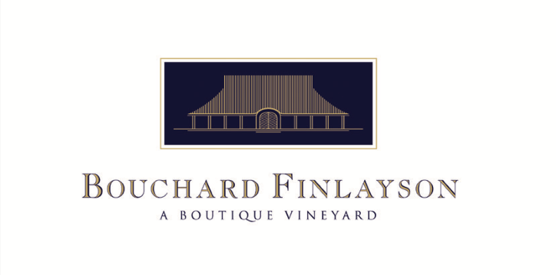
One of the most exciting additions to our list in recent years is the inclusion of the wines from our winery in South Africa, Bouchard Finlayson, set up in 1989. Collaboration has always been a part of this wine estate, which is today owned by the Tollman family of The Red Carnation Hotel Collection and collaboratively run by Victoria Tollman and Peter Finlayson.

White Wine
Glass Bottle
Blanc de Mer, Riesling Blend 11 42
Walker Bay, Sauvignon Blanc 12.5 55
Sans Barrique, Chardonnay (Unoaked) 14 55
Crocodile’s Lair, Chardonnay (Oaked) 15 60
Missionvale, Chardonnay (Oaked) 17 70

red Wine

Hannibal, Sangiovese, Syrah 22 85
Galpin Peak, Pinot Noir 23 90
Téte de Cuvée, Galpin Peak, 55 215
Pinot Noir 2017

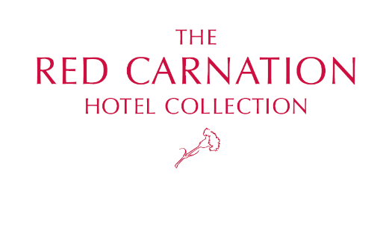

HOT BEVERAGES

Pot of Tea 5.5
Choice of Ashford Castle’s Blend
& Selected Fine Speciality Teas

Black Teas
Irish Breakfast, Ashford Blend, English Breakfast
Darjeeling Summer Gold, Afternoon Gold
Light and Late (decaffeinated)

Flavoured Black Teas
Earl Grey, Irish Whiskey Cream, Masala Chai

Green Teas
Green Dragon, Jasmine Pearls, Morgentau

Infusions
Pure Camomile, Mint Nana, Rooibos

Coffees 5.5
Americano, Espresso, Mocha
Cappuccino, Latte, Caramel Macchiato

TREATS FOR YOUR TEA

Salted Caramelia Shortbread 7.5
Vanilla Shortbread, Salted Caramel Cremeux

Gluten Free Cookies 8.5
Golden Raisin – Pecan Nut

Freshly Toasted Fruit Scones 7.5
Clotted Cream, Lemon Curd, Fruit Jam

All of our dishes are freshly prepared, please allow adequate preparation time

If you require information on the allergen content of our food, please ask a member of our staff and they will be happy to assist you

STARTERS

Bea’s Chicken Noodle Soup 12.5
Clear Chicken Noodle Soup – Baked Chicken Parcel
Blanc de Mer, Riesling Blend, Gls 11

Roast Tomato Soup 9.95
Savoury Granola – Rosemary & Orange Cream
Walker Bay, Sauvignon Blanc, Gls 12.5

Castle Caesar Salad
Cos Lettuce – Parmesan Shaving – Roasted Smoked Streaky Bacon – Fresh Anchovy – Focaccia Bread
Mrs Tollman's Caesar Dressing 11.5
With Roast Irish Chicken Breast 14.5
With Marinated Wild Prawns 17.5
Crocodiles Lair, Chardonnay (oaked), Gls 14

Smoked Salmon, Prawn & Avocado Salad 18.5
Mango Salsa – Seasonal Leaves
Missionvale, Chardonnay (Oaked), Gls, 17

Irish Charcuterie Sharing Board for two 28.5
Sourdough Bread – Apple & Fig Chutney
Pickled Carrots – Gubbeen Salami
Gubbeen Chorizo – Venison Saucisson
Connemara Beef Bresaola – Air Dried Lamb
Hannibal, Sangiovese, Syrah, Gls. 22

HOT DISHES

Traditional Fish and Chips 25
Fillet of Wild Cod in Beer Batter – Pickled Cucumber
Blanc de Mer, Riesling Blend, Gls 11

Chicken Schnitzel 22.5
Mrs Tollman’s Cabbage – Chunky Chips
Galpin Peak, Pinot Noir Gls 23

Ashford Kitchen Beef Burger 22.5
Sweet Pepper Relish – Cooleeney Farmhouse Cheese
Toasted Bun – French Fries – Pickled Cucumber
Pascual Toso, Malbec, Gls 15

Atlantic Fish Cake 24.5
Wasabi Aioli – Sesame Cucumber & Ginger Salad
Sans Barrique, Chardonnay (unoaked), Gls 14

Galway Farm Goat Cheese Tortellini 21.5
Creeny Cheese – Romesco – Chilli Oil
Spinach – Cherry Tomato – Roasted Almond
Crocodiles Lair, Chardonnay (oaked), Gls 14

Angus Beef Fillet 36
Portobello Mushrooms - Pomme Pont Neuf
Truffle Aioli
O’Dwyer, Cabernet Sauvignon, Gls 33
Vegetable Tajine 20.5
Chick Pea – Kale – Sweet Potato
Galpin Peak, Pinot Noir Gls 23

Dooncastle Oysters

The Galway International Oyster & Seafood Festival is the oldest oyster festival in the world and the most internationally recognised Irish festival after St Patrick’s Day. Deemed one of Europe’s longest-running food extravaganzas, this usually takes place the last weekend of September. We are pleased to serve Dooncastle Oysters, grown sustainably off the coast of Connemara in natural waters.

Dooncastle Oysters, N.2
3 Oysters 9
6 Oysters 18
12 Oysters 36

Oysters Kilpatrick
3 Oysters – Grilled With Spinach & Bacon 12

Sans Barrique, Chardonnay (Unoaked) Gls. 14

Champagne Tasting
Lanson Père et Fils,
Lanson Rosé Label,
Lanson White Label
€ 31.00 per tasting

Recipes & Dishes Courtesy of
Bea Tollman

“A LIFE IN FOOD”
MY ALL-TIME FAVOURITE RECIPES
(Available for Sale in the Boutique)

All of our dishes are freshly prepared, please allow adequate preparation time

If you require information on the allergen content of our food, please ask a member of our staff and they will be happy to assist you

SIDES

Chunky Chips 4.5
Sautéed Baby Spinach 5
French Fries 4.5
Tender Stem Broccoli & Flakes Almond,
Sesame Dressing 5
Green Salad with Sumac
All Spice & Pickled Red Onion 5
Truffle Aioli 3

SANDWICHES

Our Selection of Sandwiches are served with Seasonal Leaves tossed with Roasted Mixed Seeds,
Potato & Root Vegetable Crisps,
Lemon Juice & Honey Dressing

Roast Irish Chicken Fillet 17.5
Avocado – Chilli Yoghurt – Beef Tomato
Seasonal Leaves

Ashford Castle Club 19.5
Toasted Sandwich of Crispy Streaky Bacon
Chicken – Egg – Cos Lettuce – Tomato

SPECIALITY SANDWICHES

Kylemore Swiss Cheese & Tomato 17.5
on White Sourdough

French Dip 19.5
Thinly Sliced Roast Beef – Caramelised Onion
Beef Jus – Sourdough Baguette – French Fries

Organic Smoked Salmon 19.5
Mrs Tollman’s Bread – Beets – Trout Caviar – Sour Cream

DESSERTS

Sweet Wines available by the glass on request.

Traditional Apple Pie 12.5
Vanilla Scented Ice Cream

Selection of Ice Creams 12.5
Vanilla – Chocolate – Strawberry – Honeycomb
Toffee Or Chocolate Sauce

Irish Farmhouse Cheese Platter 18.5
Sourdough Crisp – Water Biscuit – Apple Jelly

Bea Tollman's Favourite Desserts

Bea’s Cheesecake 12.5
Vanilla Scented Baked Cheesecake

Rice Pudding 12.5
Salted Caramel Sauce – Caramelised Nuts
Pecan Nuts – Almond & Pumpkin Seeds

