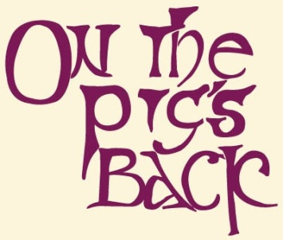

On the Pigs Back Sandwich Selection

Chicken Fillet with roast pepper, rockets leaves & harissa spiced mayo served on Arbutus wholemeal country sourdough with a selection of salads. €8.95 6

Jack McCarthy’s Cork spiced Beef Sandwich with Brie de Meaux, greens and onion relish on Arbutus wholemeal country sourdough with a selection of salads. €8.95 5, 6

Jack McCarthy’s free-range honey & mustard Ham Sandwich with greens and a red pepper relish on Arbutus wholemeal country sourdough with a selection of salads. €8.95 5,11

Plus toasties.

Gluten Free Brown Bread is also available as an alternative.

Please note that while every care is taken in preparing these allergen free dishes we also use other products containing gluten, nuts and other allergens in our kitchen.

Some of our side salads served with main courses may contain nuts.

Any allergies please inform your server so we can do the utmost to accommodate you. .
All of our beef, chicken fish & eggs are 100% Irish origin & we source most of ingredients from local suppliers.

List of Allergens: 1 Eggs, 2Fish, 3Soy, 4Nuts, 5Milk, 6Gluten, 7Shellfish, 8Sesame, 9Celery, 10Lupin, 11Mustard, 12 Sulphites, 13 Molluscs, 14 Peanuts

