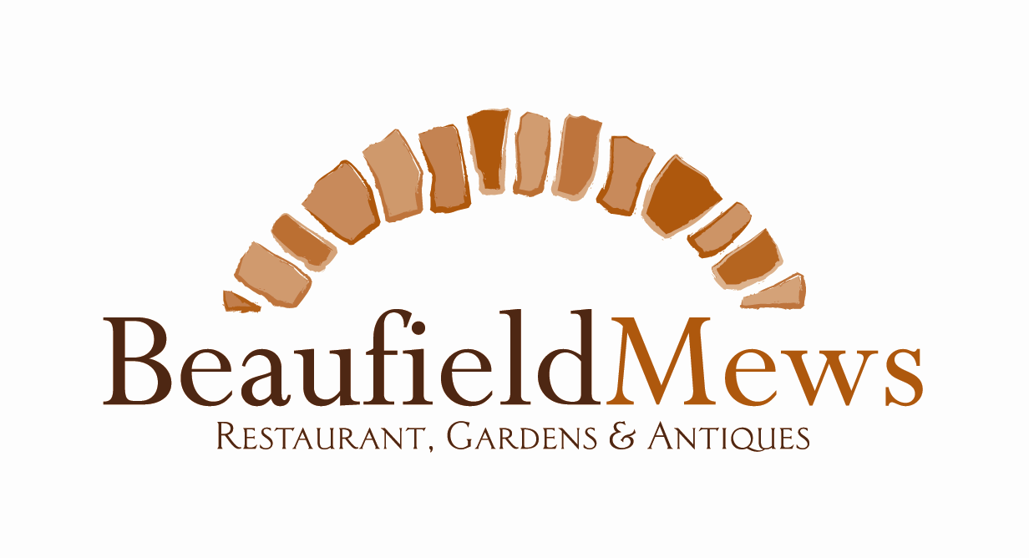

Dublin’s oldest restaurant
Laying the healthy foundations to our future customers
Menu based on kids up to 12 years of age

STARTERS
Fruit kebab, skewered apple, plum, orange & pineapple
Hummus & rice cakes (GF)
Tomato and Basil Soup, served with homemade brown bread

~~~~~

MAINS

Homemade lasagne, fresh turkey mince

Monterey Jack Mac & Cheese

Baked macaroni and Monterey jack cheese (Add Bacon for €1.00)

Puff pastry pesto pizza

Puff pastry base with pesto chicken & rocket

Curry with Beef & rice

Mild sirloin of beef and long grain rice (GF)

Cod & Salmon Fish Cakes

Pan fried salmon, cod and potato fish cakes with dressed leaves

All our main courses are served with batons of carrots & mash potatoes

~~~~~
DESSERTS
Vanilla & chocolate ice cream with fresh strawberries
Fresh Fruit Salad
Chocolate brownie (Nut Free)

€10 for 2 courses, €12.99 for 3 courses
+10% service charge
(GF) Indicates dishes are gluten free. Kitchen is of a mixed environment. Low risk of cross-contamination may occur.
‘From our family to yours’

