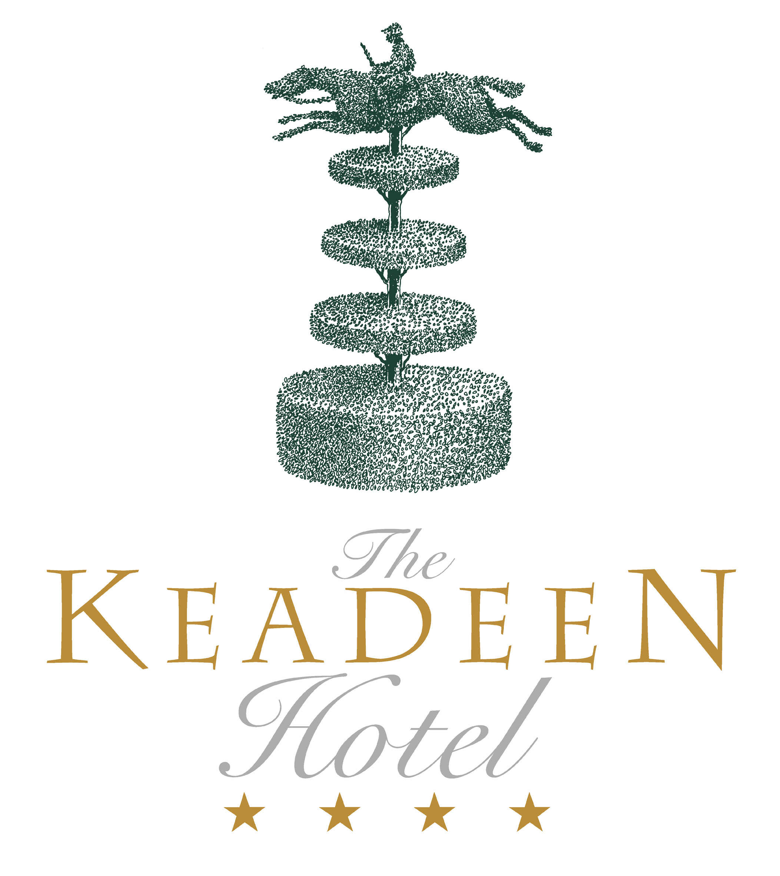

Derby Restaurant
Wine List

House Wines

White

Bottle
France 1. Cuvee, Georges Du Boeuf 22.95
Dry and clean tasting in the Macon style.

Australia 2. Keenan’s Bridge, Unoaked Chardonnay 28.95
Has vibrant fruit flavours so apparent on the nose and palate.
This wine is a pure expression of Chardonnay in the Riverland.

Red

France 3. Cuvee, Georges Du Boeuf 22.95
Medium bodied fruity red from Burgundy’s most famous wine
producers.

Australia 4. Keenan’s Bridge, Cabernet / Shiraz 28.95
Aromas of blackberries, ripe plum and herbaceous fruit characters
dominate the nose. On the palate, this lively, medium bodied
wine displays ripe luscious red berry fruit.

White

Burgundy 6. Chablis, J Moreau et Fils 39.95
Made from the Chardonnay grape. It is green gold, aromatic, elegant
with well balanced dryness.

Burgundy 7. Pouilly Fuisse, Louis Jadot 47.50
A stylish wine of medium body and depth with a fine balance of
delicious ripe generous fruits. Nice touches of gentle oak on the finish.

Loire 8. Pouilly Fume, Domaine Chatelain 52.50
Upfront fruits. Acidity in harmony. Good definition and length.

Alsace 9. Gewurztraminer, FE Hugel et Fils 38.50
Full, rich and spicy with a very aromatic flavour.

Italy 10. Serego Alighieri, Bianco 31.95
This is a modern style wine made from the Sauvignon and Garganega
grapes on the historic Serego Alighieri Estate. It is a refreshingly dry
wine with good structure and finish.
Spain 11. Pazo San Mauro, Albarino 45.50
A light to medium bodied dry wine with pretty floral aromas and a
delicate fragrance.

N Zealand 13. St Clair, Premium Sauvignon Blanc 32.95
St Clair’s award-winning Sauvignon Blanc is made in the Marlborough
region. The wine has intense gooseberry fruit flavours, yet elegant with
a long refreshing finish.

California 14. Casa Silva Chardonnay Reserva 38.50
Complex, full bodied with ripe peachy melon flavours and a
good finish

California 15. Trinchero, Napa Cellars Chardonnay 32.95
The palate showcases huge fruit flavours reminiscent of tropical fruit salad balanced by a layer of lemony acidity accentuating the long, polished finish.

Red
Bottle

Bordeaux 17. Chateau Teyssier, Grand Cru, St Emilion 57.50
It shows great richness and concentration, while being quite youthful.
and drinks very well now.

Bordeaux 18. Chateau lamrache Bordeaux Superieur 30.95
A wine with a developed fruity nose, soft and appealing, with good
grip & supple tannins. Fruit heavy & rich. Elegant with good length.

Burgundy 19. Fleurie, Domaine de Poncereau, Louis Jadot 42.50
This single estate Fleurie made from the Gamay grape has typical
raspberry fruit flavours with a medium body and good finish.

Rhone 20. Chateauneuf de Pape, La Bernadine, M. Chapoutier 56.50
Rich, powerful, full bodied generous wine with excellent finish and a
hint of spice.

Italy 21. Campofiorin 35.50
This unique wine is made by “Ripasso” method which semi dries the
grapes and then re-ferments. This results in a classic wine which is rich,
full bodied, round and velvety with an ageing capacity of 15 years.

Italy 22. Amarone, Costasera Classico 59.95
Nicely mature, spicy-tasting, featuring mellow aromas and rather
lean fruit flavours.

Italy 23. Tignanello, Antinori 113.00
Rich, powerful, flavoursome wine packed with fruit and wonderful
undertones and oak flavours.

Italy 24. Peppoli, Chianti Classico, Antinori 38.50
This is a new, modern style of Chianti Classico. Lighter and more
fragrant with well balanced fruit and a good structure.

Spain 25. Marques de Riscal 1860, Tempranillo 30.95
A spicy bouquet leads to a glorious smooth palate with ripe juicy
blackcurrant fruit flavours and well-integrated oak, together with
a long finish

Sparkling
Bottle
26. Freixenet Cava, Sparkling Wine 37.00
A delicate wine with long lasting bubbles. Full of flavour and fun.

Champagne
Bottle
27. Veuve Clicquot, Yellow Label 105.00
Intense fruit nose, fine mousse, flowery, fresh bouquet. Balance
and length.

28. Moet & Chandon 85.00
Elegant, rich, buttery aroma. A classic delicate buttery fruit round style.

29. Bollinger, Special Cuvee 220.00
Fine biscuit taste which exhibits excellent balance and it is crisp, fresh
and elegant.

Half Bottles White

Chile 30. Casa Silva Coleccion Sauvignon Blanc 15.50
Appealing aromas of fresh Apricots & Mango’s with crunchy white
Fruits & a subtle honey backbone on the palate

France 31. Chablis Domaine le Verger – Alain Geoffroy 23.00
Well structured & full bodied with a stylish fruity finish, a really
fine Chablis from a top class producer.

France 32. Sancerre, Domaine Vacheron J.L Vacheron 28.00
Classic Sauvignon taste of gooseberries & grapefruits, dry with a
crisp finish.

France 33. Muscadet de Sevre-et-Maine Sur Lie, Chateau de la Cassemichere 17.00
Dry and fresh wine with excellent fruit. Clean finish.

France 34. Cuvee, Georges Du Boeuf 12.50
Dry and clean tasting in the Macon style.

Half Bottles Red

France 35. Chateau Le Vivier, Medoc 22.00
An elegant wine from a good year with red dark berry fruit and oak age
blending well together.

France 36. Fleurie, Domaine de Poncereau, Louis Jadot 22.00
This single estate Fleurie made from Gamay grape has typical raspberry
fruit flavours with a medium body and good finish.

France 37. Cuvee, Georges Du Boeuf 12.50
Medium bodied fruity red from Burgundy’s most famous wine producers.

Italy 38. Villa Antinori, IGT Toscana 27.00
This new improved blend though still predominantly Sangiovese is a
well structured rich complex full bodied wine with a long finish.

