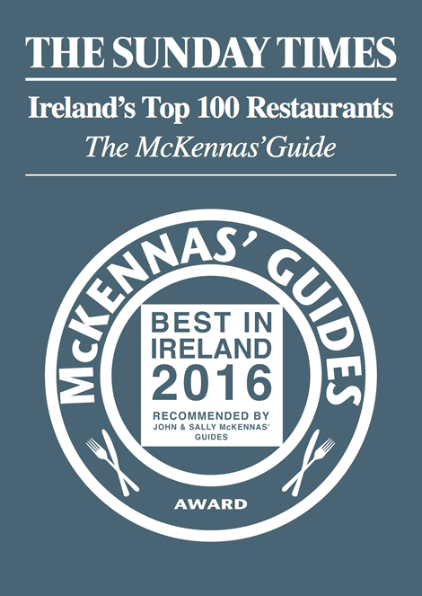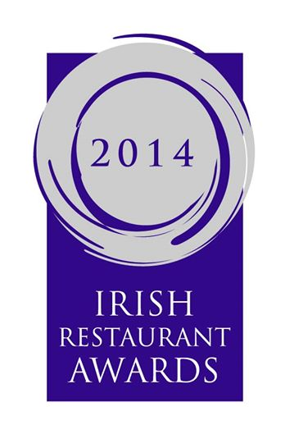

Early bird menu
Fresh crab salad with basil mayonnaise (2 euro suppl.)

Sea food ravioli with creamy smoked salmon sauce

Smoked Gubbeen cheese tartlet with ratatouille and peppers coulis

Smoked tuna carpaccio, rucola lemon oil dressing & parmesan foam

Warm chicken salad with pancetta balsamic vinegar & pine nuts

Soup of the day
Main courses
Pan fried Irish chicken fillet with mozzarella Parma ham & white wine

8oz rib eye steak with caramelized onions & brandy pepper sauce (3 euro suppl.)

Grilled fillet of sea bass with fresh tomato capers and olives salsa

Confit of duck with champ & balsamic reduction

Ricotta and spinach ravioli with tomato and basil sauce

Sea food risotto

Home made Dessert
Dolci misti della casa
Vate rate @ 9 3 courses €28.50
All our beef is born & reared in Ireland.
Allergen information, please ask for allergen content check list

