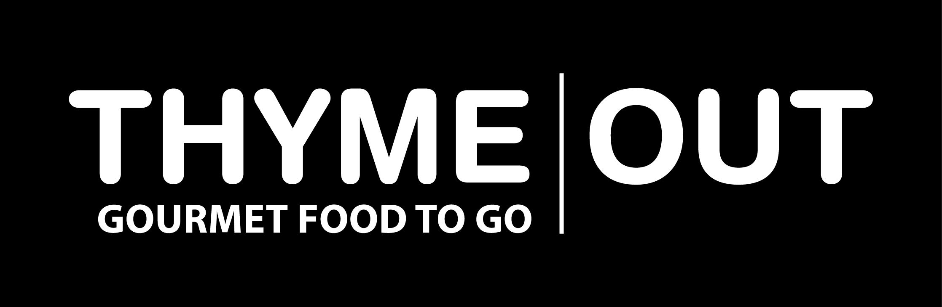
FREE LOCAL DELIVERY

33/34 CASTLE STREET, DALKEY, PHONE 01 2851999
HOT BUFFET MENU (Serves 20 guests)

CHOOSE ONE MAIN
Beef Stroganoff (flour free)

Pepper pot Beef (flour free)

Beef Bourguignon (corn flour)

Chicken Tarragon (flour free)

Chicken Stroganoff (flour free)

Rice with freshly chopped coriander
or
Creamy Dauphinoise potatoes

3 Artisan Breads

2 Lemon Curd Meringue Roulades

@ €12.75 per person €255.00

If this suggested menu does not suit your requirements, just let us know and we would be delighted to assist with a menu
for you.

FREE LOCAL DELIVERY

33/34 CASTLE STREET, DALKEY, PHONE 01 2851999
HOT BUFFET MENU (Serves 20 guests)

CHOOSE ONE MAIN
Beef Stroganoff (flour free)

Pepper pot Beef (flour free)

Beef Bourguignon (corn flour)

Chicken Tarragon (flour free)

Chicken Stroganoff (flour free)

Rice with freshly chopped coriander
or
Creamy Dauphinoise potatoes

3 Artisan Breads

2 Lemon Curd Meringue Roulades

@ €12.75 per person €255.00

If this suggested menu does not suit your requirements, just let us know and we would be delighted to assist with a menu
for you.

