Inch House Midweek Menu

Three Course €35.00
Two Course €29.00
Starters:

Baked Atlantic mussels with garlic crumb crisp topping & finished with capers

Salad of Feta, olives, sundried tomato & Crowe’s farm bacon lardons served with our Inch House honey ustard dressing

Cream soup of evening

Inch House Black Pudding tart with red onion marmalade & Gortnamona goats cheese (Black pudding available Gluten Free)

Cajun Irish chicken salad served warm with sweet chilli mayonnaise

Parisenne of Melon served with Boulaban farm fruit sorbet

************************************************
Optional starters:

Inch House traditional black pudding topped with Gortnamona Goats cheese with caramelised onions & Inch House mixed berry compote
(€3.00 supplement) (Black pudding available Gluten Free)

Barbequed salmon from the Burren Smokehouse with Inch House plum Chutney
(€5.00 supplement)
Our salad leaves come from a local organic grower called the green bowl company

Main Course:

Irish sirloin 8oz steak cooked to your liking & served with creamy pepper sauce

Oven baked supreme of Irish chicken wrapped in Crowe’s farm streaky bacon and served with creamed chestnut mushrooms from Fahey’s farm

Honey roasted Confit of Irish Silver Hill duck leg served with sweet potato and courgette mash & Inch House honey & bitter orange sauce

Roast Aubergine stuffed with roast vegetables and topped with Cooleeney cheese
Baked escallope of Salmon served with soy and sesame stir-fry

All main courses served with selection of local vegetables & steamed potatoes & garlic potatoes.
Our potatoes are grown here at Inch House along with herbs and salads in season.
Optional Main courses:

*Irish Fillet 12 oz steak served with creamy wholegrain mustard mash & red onion sauce (€13.00 supplement)

* Grilled fillets of Seabass stuffed with roast vegetables & dressed with pesto cream sauce (€9.00 supplement)

*Rack of Irish Lamb served with herb stuffing & roast garlic jus
(€11.00 supplement)
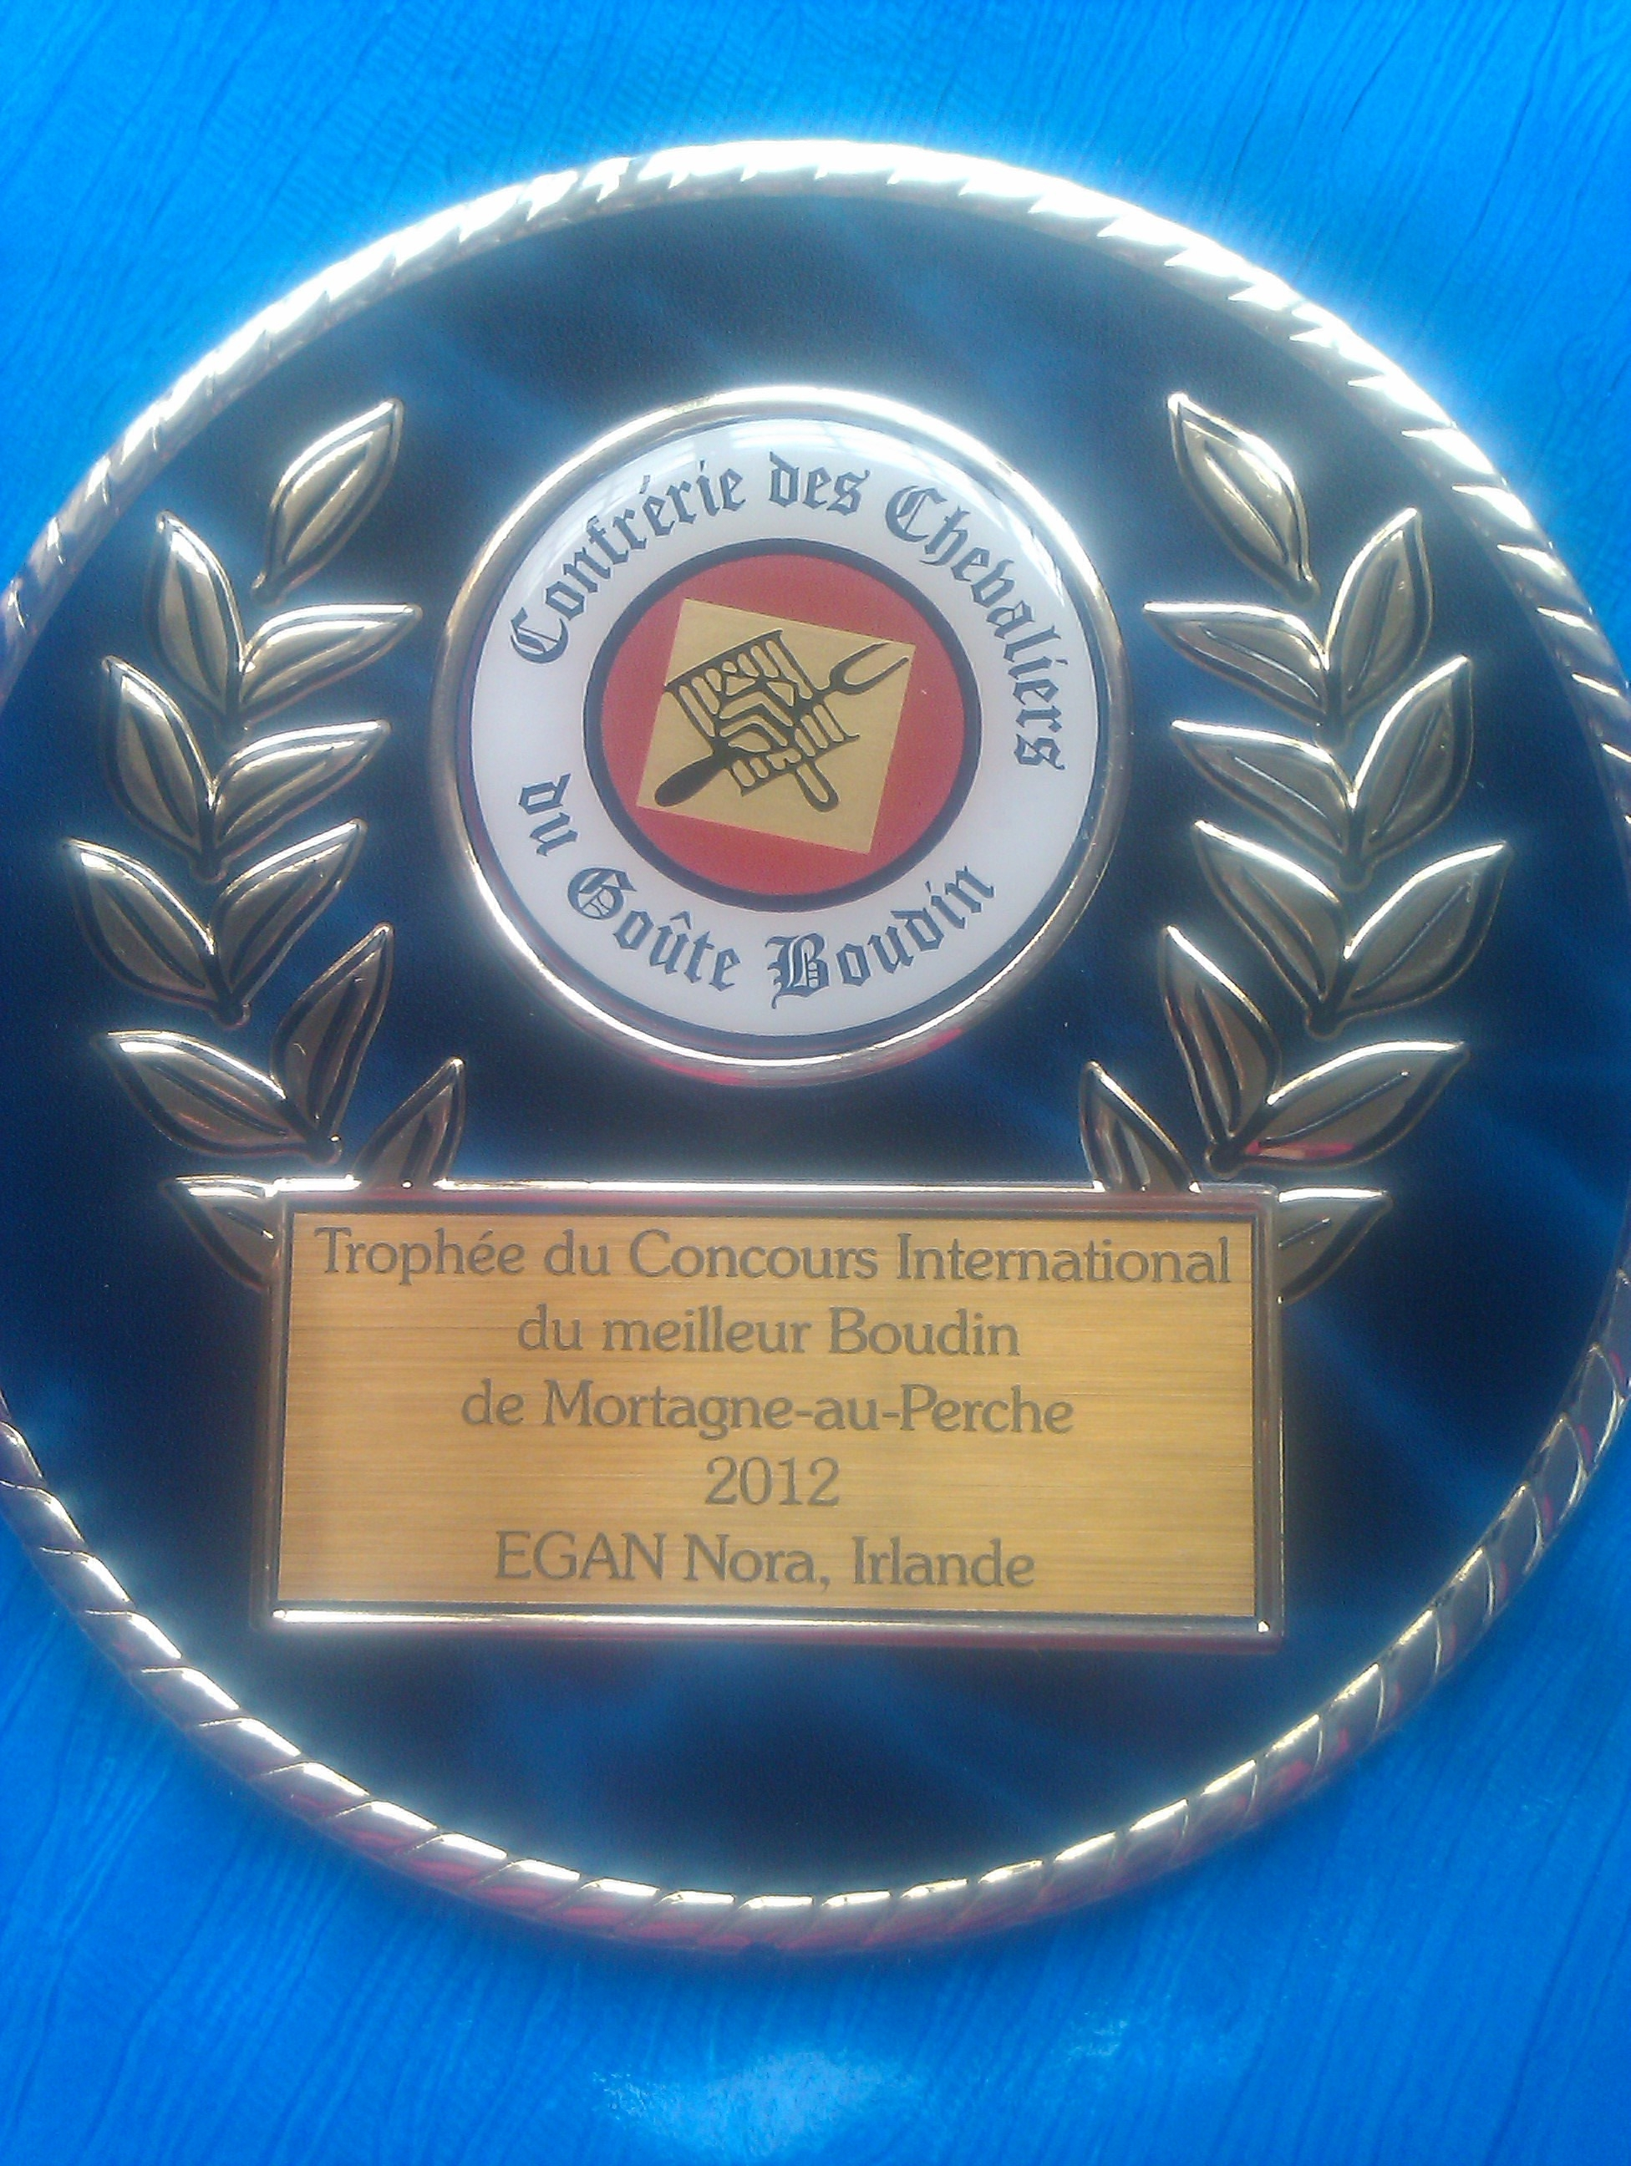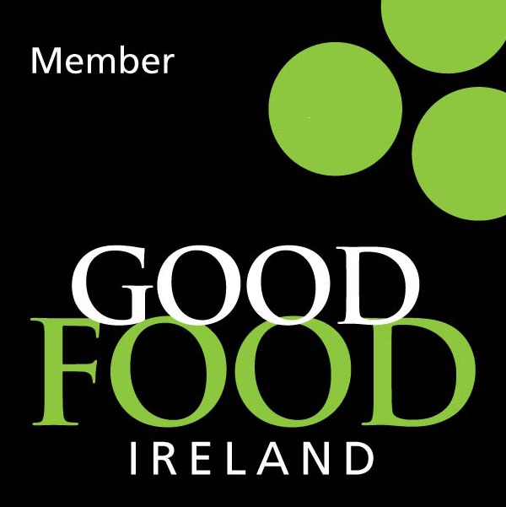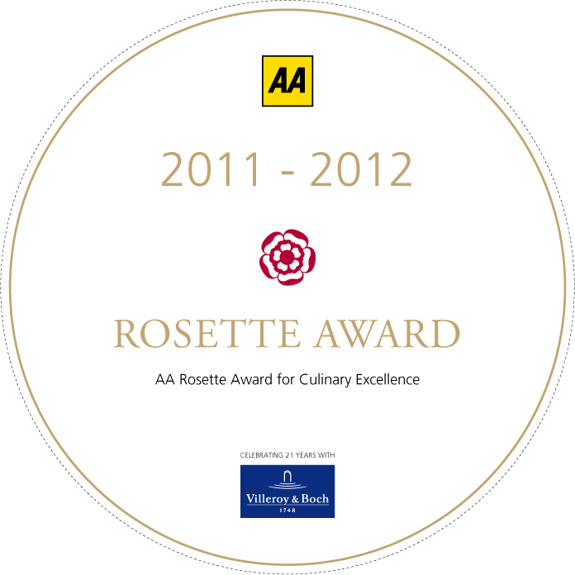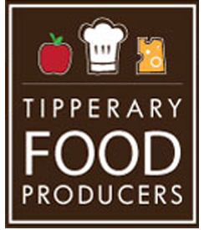
Midweek Dessert Menu
Shortbread ginger biscuits
Shortbread ginger biscuits served with cider & apple compote with chantilly cream

Strawberry Toblerone cheesecake €8.50
Strawberry Toblerone cheesecake served with Bailey’s scented chocolate sauce

Inch House Style sticky toffee pudding €8.50
Inch House sticky toffee pudding served warm with vanilla ice-cream & chocolate crème anglaise

Hazelnut Meringues €8.50
Hazelnut Meringues served with fresh cream and caramel sauce

Inch House Dessert Plate €11.00
A selection of Five Desserts from our Pastry Chef

Homemade Ice-cream €8.00
Selection of Inch House Homemade Ice-cream served with Fresh Cream

Fruit Sorbets €8.00
Selection of Fruit Sorbets complimented with Seasonal Fruit

Selection of Farm House Cheese €12.00
A selection of Farm House Cheese from Tipperary & across Ireland
Selection of Herbal & Fruit Teas Available €2.50
Espresso Ristretto €2.50
One Fluid Ounce, Very Strong.
Espresso Macchiato €2.50
Single Espresso with Foamed Milk
Espresso Doppio €3.50
Double Espresso
Americano €3.50
Double Espresso topped with Hot Water

Tea/Coffee €2.50
Preseco by the glass €10.00
Irish Coffee €5.00
Tia Maria Coffee €5.00
Baileys Coffee €5.00
Brandy Coffee €5.50
Middleton Very Rare €14.00

Caffe Latte €3.50
Double Espresso with three Times as Much Hot Milk.
Caffe Mocha €3.50
One Third Espresso One Third Chocolate and One Third Milk
Decaffeinated Coffee
Available in all of the above Drinks
Churchill’s Vintage Port 1991 €10.00
Jameson Distillery 12 Years €8.50
Camus XO Supérieur Cognac €9.50
Camus Cognac V.S. €6.50
Martel XO €8.00

